Name: Mai Duc An

Student ID: 20210008

**Data Modeling**

1. Conceptual data model

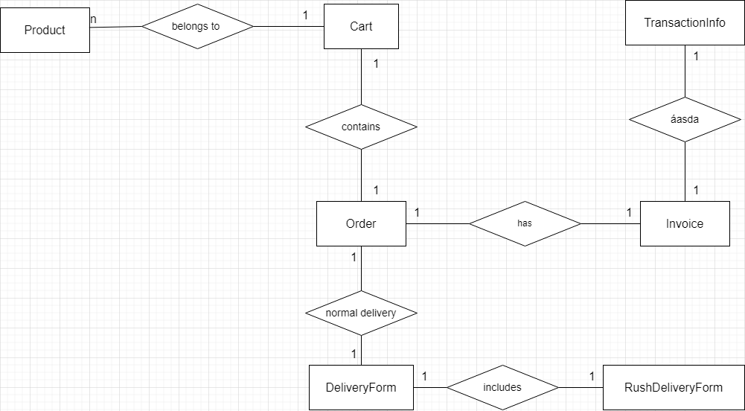

1. Logical data model

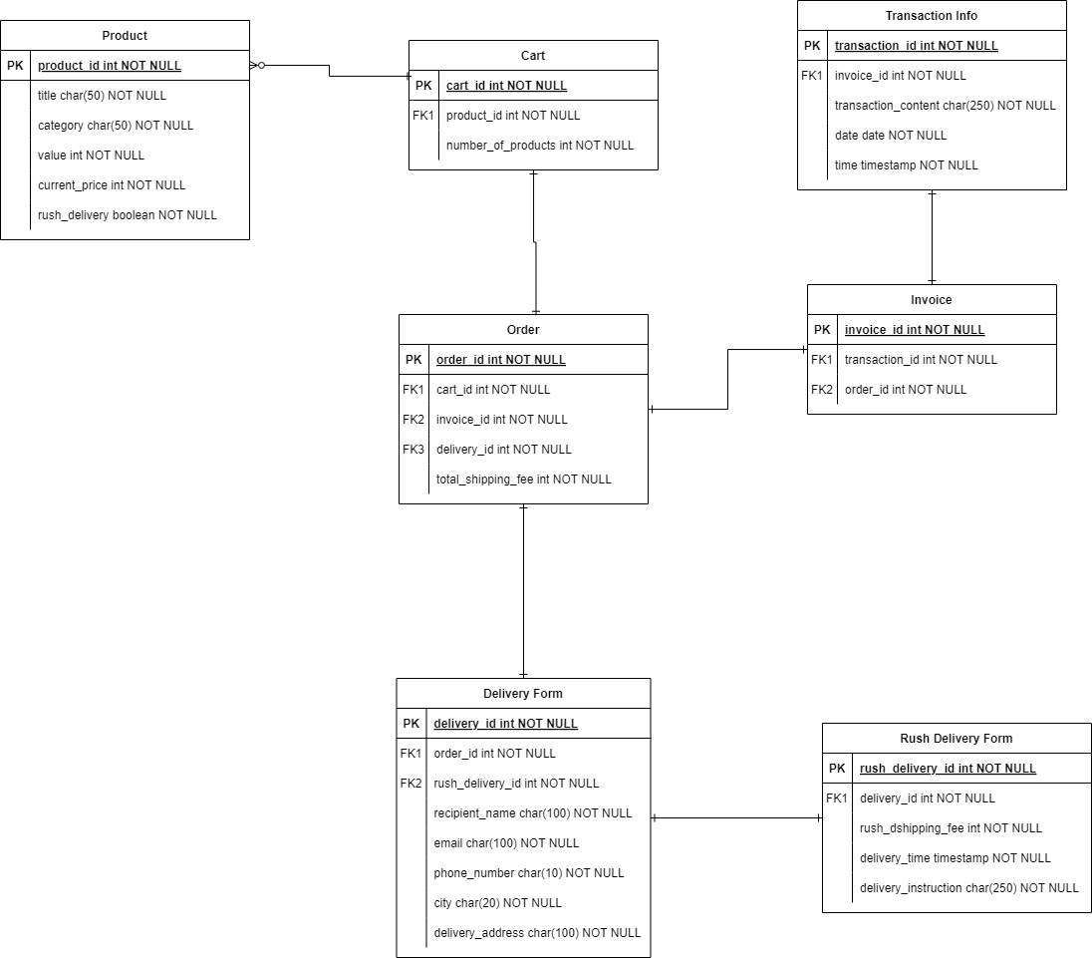

1. Physical data model

Product:

| CREATE TABLE Product (  product_id INT NOT NULL PRIMARY KEY,  title CHAR(50) NOT NULL,  category CHAR(50) NOT NULL,  value INT NOT NULL,  current_price INT NOT NULL,  rush_delivery BOOLEAN NOT NULL ); |
| --- |

Cart:

| CREATE TABLE Cart (  cart_id INT NOT NULL PRIMARY KEY,  number_products INT NOT NULL,  FOREIGN KEY (FK1_product_id) REFERENCES Product(product_id)); |
| --- |

Order:

| CREATE TABLE Order (  order_id INT NOT NULL PRIMARY KEY,  total_shipping_fee INT NOT NULL,  FOREIGN KEY (FK1_cart_id) REFERENCES Cart(cart_id),  FOREIGN KEY (FK2_invoice_id) REFERENCES Invoice(invoice_id), FOREIGN KEY (FK3_delivery_id) REFERENCES Delivery_Form(delivery_id)); |
| --- |

Delivery Form:

| CREATE TABLE Delivery_Form (  delivery_id INT NOT NULL PRIMARY KEY,  recipient_name CHAR(50) NOT NULL,  email CHAR(100) NOT NULL,  phone_number CHAR(10) NOT NULL,  city CHAR(20) NOT NULL,  delivery_address CHAR(100) NOT NULL,  FOREIGN KEY (FK1_order_id) REFERENCES Order(order_id) FOREIGN KEY (FK2_rush_delivery_id) REFERENCES Rush_Delivery_Form(rush_delivery_id) ); |
| --- |

Rush Delivery Form:

| CREATE TABLE Rush_Delivery_Form (  rush_delivery_id INT NOT NULL PRIMARY KEY,  rush_shipping_fee INT NOT NULL, delivery_time TIMESTAMP NOT NULL, delivery_instruction CHAR(250), FOREIGN KEY (FK1_delivery_id) REFERENCES Delivery_Form(delivery_id) ); |
| --- |

Invoice:

| CREATE TABLE Invoice (  invoice_id INT NOT NULL PRIMARY KEY,  FOREIGN KEY (FK1_transaction_id) REFERENCES Transaction_Info(transaction_id) FOREIGN KEY (FK2_order_id) REFERENCES Order(order_id)); |
| --- |

Transaction Info:

| CREATE TABLE Transaction (  transaction_id INT NOT NULL PRIMARY KEY,  transaction_content CHAR(250) NOT NULL,  date DATE NOT NULL,  time TIMESTAMP NOT NULL, FOREIGN KEY (FK1_invoice_id) REFERENCES Invoice(invoice_id)); |
| --- |